

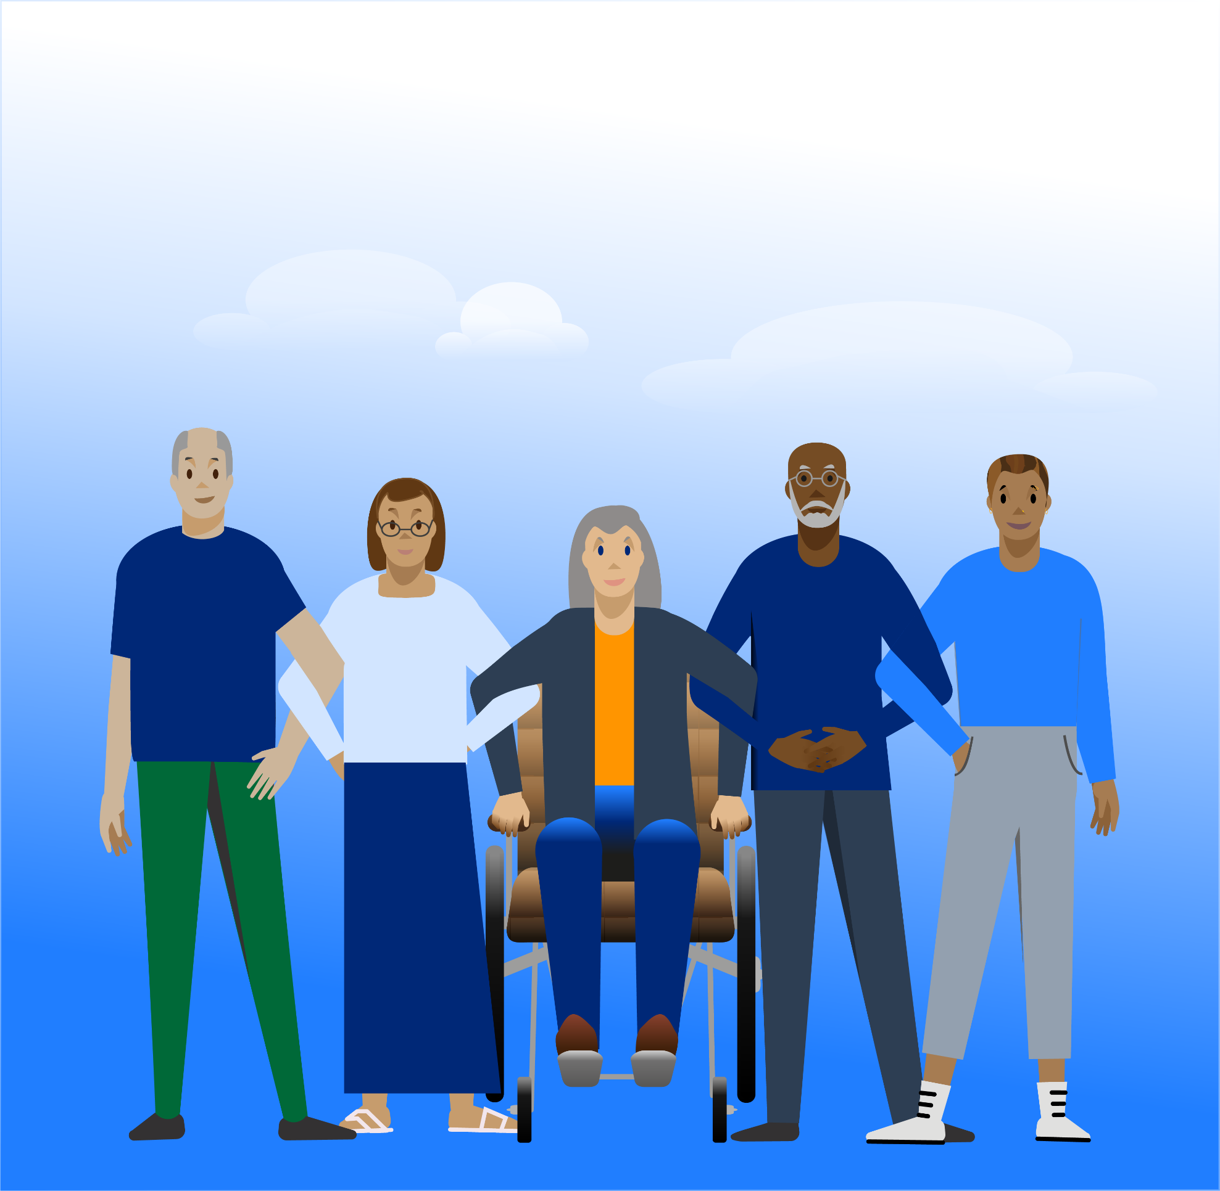
Together we are help and hope for everyone living with dementia
Companion Call Volunteer
Role description

Why we need you
Companion Call Volunteer
People with dementia and their carers can be vulnerable to isolation and loneliness.
Companion call volunteers make regular phone calls and have a friendly chat with somebody affected by dementia. This makes such a difference to people and they really look forward to these calls.

What you will be doing
- Telephoning somebody affected by dementia on a regular basis, usually weekly, to have a friendly social conversation.
- Chatting with the same people each week to provide continuity and familiarity.

- Providing feedback about the calls by completing a brief online form and a regular catch up call with your volunteer manager.
This role will suit you if you
- Want to make a positive difference to people affected by dementia.
- Have excellent communication skills, are a good listener and enjoy conversations with a variety of people.
- You are patient, flexible and able to commit to making regular calls.

- Have basic IT skills and internet access.
What you can expect from us
- We will make you feel welcome, included and respected.
- You will receive training, ongoing supervision and support.
- You can claim pre-agreed out of pocket expenses (e.g. travel) in line with our policy.
- We’ll keep you up to date with relevant policies and procedures that apply to your role.

- You’ll have access to learning, development and engagement opportunities for volunteers.
What we need from you
To ensure the safety and security of people with dementia we ask for:
- This role requires a basic criminal record check. A criminal record will not necessarily stop you being able to carry out this role.

- Two references and proof of identity.
- To put the role into practice most effectively volunteers are recommended to continue for at least 6 months.
- Learning at the start will take approximately 2 hours, followed by periodic refreshers.
- You will need to have your own telephone and your own computer/tablet/smartphone with internet access.


