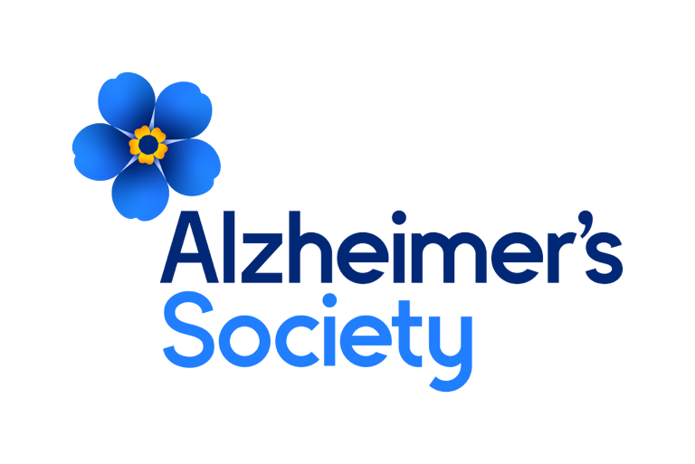
Medical Writer: Trial Finder – FTC 24 months


It will take a society to beat dementia. Alzheimer’s Society.
Job description

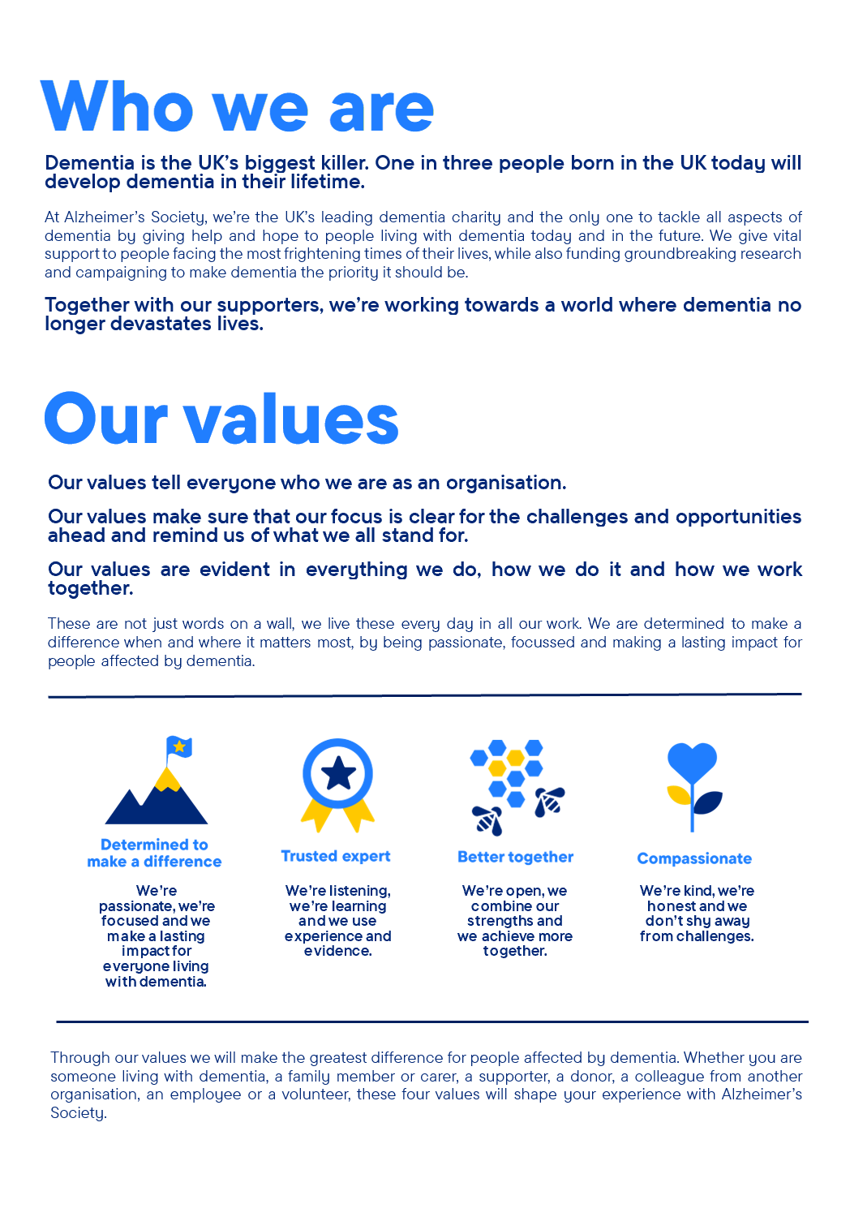

Medical Writer: Trial Finder – FTC 24 months

Position in the organisation
This post reports to the Research Participation Manager and is part of the Research and Influencing (R&I) directorate.

The postholder will work closely with the Research Nurse Programme, the Research Communications team, the wider Participation team and external UK Dementia Trials Network colleagues to maintain the Alzheimer’s Society UKDTN Trial Finder platform and raise awareness of clinical trial opportunities in mild cognitive impairment and dementia available across the United Kingdom.

Purpose of this role
At Alzheimer’s Society we are advisors, supporters, fundraisers, researchers, influencers, communicators, technical specialist and so much more. We are volunteers, we are employees, and together we are here to make a difference to the lives of people with dementia and their carers.

The Alzheimer’s Society UKDTN Trials Finder is an online, open access, platform hosted on Alzheimer’s Society’s website and funded by the UK Dementia Trials Network (the UKDTN). The Trials Finder will provide people affected by mild cognitive impairment or dementia, their loved ones, and healthcare professionals with information about available clinical trials, including details of how they can contact our Research Nurses and the appropriate NHS teams to express an interest in taking part in a trial. The Trials Finder will play a key role in achieving the UKDTN and the Society’s ambition of enabling more people living with dementia to access and engage with appropriate clinical research opportunities regardless of where they live.

The Medical Writer will play a central role in transforming complex clinical trial information and study results into clear and accurate lay summaries for inclusion in the trial finder platform. Passion for improving awareness of, and access to, dementia clinical research opportunities is vital as is confidence in working across a wide range of clinical and research stakeholders to manage competing demands effectively.

Working hand-in-hand with Industry, NHS and academic stakeholders the postholder will be responsible for ensuring all study listings are accessible and accurate and there is appropriate supporting content available across the Society’s website. There will be an occasional requirement to support the Research Communications team with communications activity relating to the Clinical Trials Finder.

We are looking for someone who exemplifies our values, someone who is: Determined to make a difference when and where it matters most. A trusted expert who believes in working Better together and demonstrates true Compassion.

Key accountabilities and responsibilities
- Develop clear, accessible lay summaries of clinical trial information, study designs, results, and safety data, using plain English and best-practice accessibility standards, including for users with cognitive impairment.

- Liaise with clinicians, researchers, trial sponsors, and study teams to clarify information, verify accuracy, and ensure summaries reflect current protocols, recruitment status, and results.

- Manage the workflow of upcoming studies and results, prioritising effectively to meet agreed timelines for producing lay summaries.

- Upload, update, and maintain trial summaries within the content management system, ensuring all information is accurate, consistent, and up to date.

- Maintain accurate internal records and datasets relating to study listings, updates, and communications.

- Stay informed about developments in dementia research, clinical trial design, and best practice in patient-facing medical writing to continually improve content quality.

- Collaborate with Research Communications colleagues to support wider communication activities related to clinical trials, the Trial Finder platform, and public research awareness.
We are looking for someone who can…
- Adhere to all the Society’s service standards, policies and procedures.
- Comply with the data protection regulations, ensuring that information on clients remains confidential.
- Be responsible for personal learning and development, to support the learning and development of others and the whole organisation.
- Work in a manner that facilitates inclusion, particularly of people with dementia.
- Implement the Society’s health and safety policy and procedures, ensuring that all practices and procedures are undertaken in accordance with a healthy and safe working environment and that all staff and volunteers for whom you may be responsible are aware of their responsibilities in respect of their role, monitoring data and recommending action as required.
- Administrate and organise own work to ensure that it is accurate and meets quality targets, reasonable deadlines, and reporting requirements.
- Follow the Society’s management information guidelines and requirements, including ensuring appropriate monthly measures on service usage levels are collected and submitted on the services database or other systems in accordance with deadlines.

Person specification and selection criteria
Skills & knowledge | Application (A) or Interview (I)
Degree or equivalent experience in a relevant biomedical, health, or life sciences discipline, or in clinical research delivery or communications. | A
Demonstrable experience of working in a similar role in communications or medical writing | A
Excellent written and verbal communication skills, with the ability to clearly translate and explain complex scientific information to diverse audiences, including people affected by dementia. | A, I
Proven ability to build strong, professional relationships and work collaboratively with key internal and external stakeholders including clinicians, researchers and study sponsors. | A, I
Understanding of clinical research delivery within NHS, academic, or industry settings. | A
Strong organisational skills, with experience managing multiple competing tasks accurately and to a high standard. | A, I
Proactive, solution-focused approach, able to work independently and prioritise effectively to meet tight deadlines. | A, I
Professional, credible, and respectful approach, able to build trust with a wide range of stakeholders. | I
Knowledge of dementia and the dementia research landscape, and experience in a communications-focused role. | A
Strong IT skills, including proficiency in Microsoft Office 365. | A

Competencies & personal attributes | Application (A) or interview (I)
Be a team player, supporting colleagues when there are deadlines, and who knows when to ask for help themselves. | A, I
Be a self-starter and incredibly motivated. | A, I
Excellent organisational and timekeeping skills. | A, I
Excellent attention to detail. | A, I
Non-judgemental communication | A, I
Commitment to and understanding of equal opportunities | A, I
Understanding of the inclusion agenda and its relevance within a diverse society | A, I

Follow us on Twitter and Instagram @Alzheimerssoc and Like us on Facebook or check out Alzheimer’s Society YouTube channel youtube.com/AlzheimersSociety

Criminal Record Check
This post may be subject to a satisfactory Criminal Records Check, from either the Disclosure and Barring Service (England & Wales), Disclosure Scotland Check (Scotland) or AccessNI (Northern Ireland). Please select the level of Check required for this role:
Basic ☐
Enhanced ☐
Not Applicable ☐
Candidates - If you require further information regarding Criminal Records Check, then please contact: careers@alzheimers.org.uk
Hiring Managers - If you require further information regarding Criminal Records Check for this role, then please contact: Employeesupport@alzheimers.org.uk


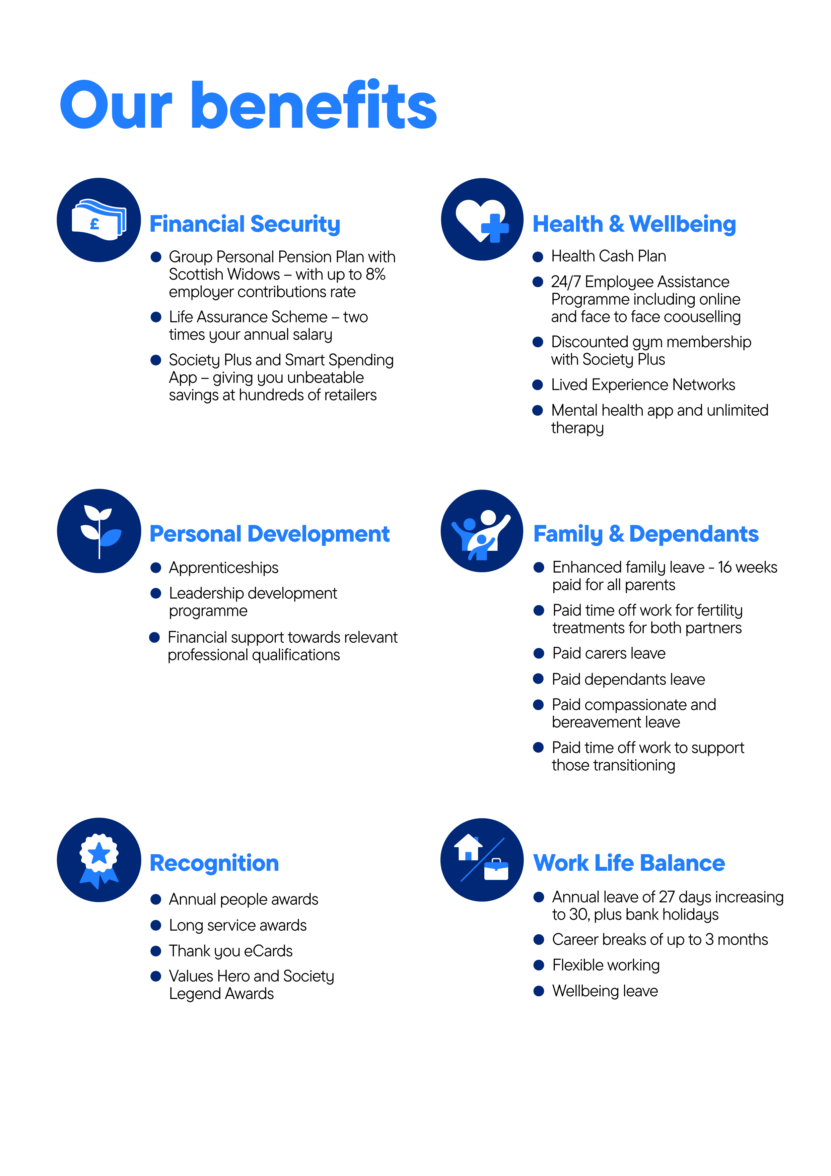
https://www.alzheimers.org.uk/sites/default/files/2024-08/alzheimers-society-how-to-talk-about-dementia-media-guide.pdf

