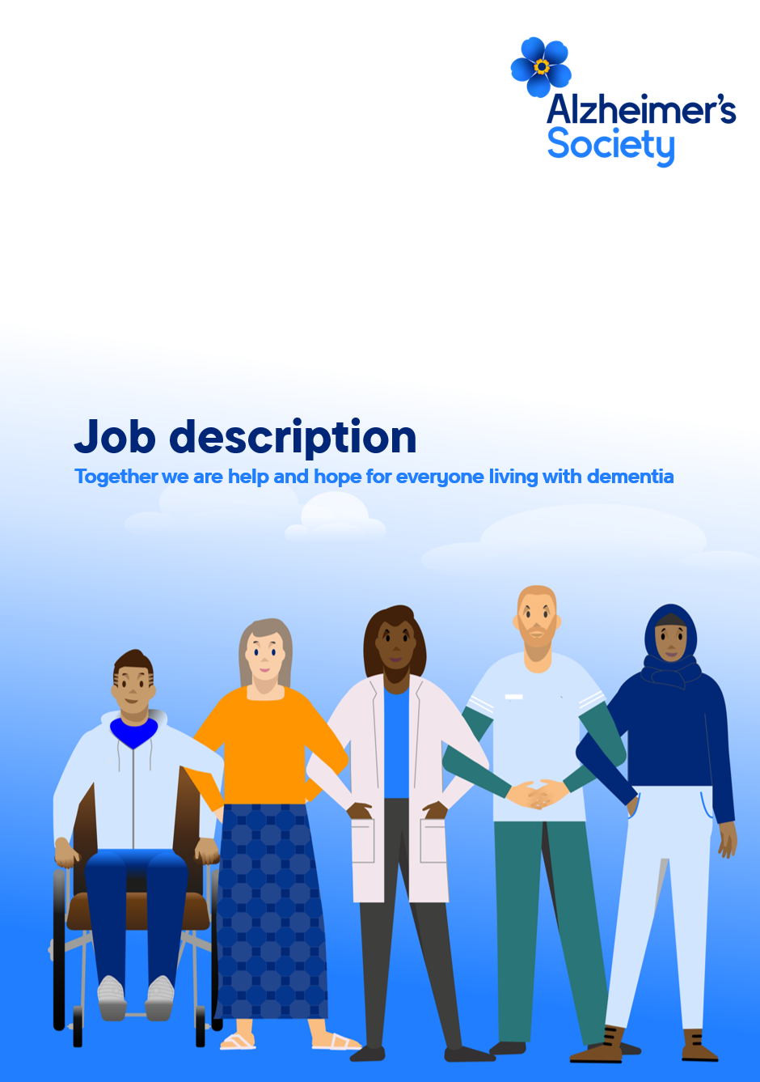

Research Grants Assistant

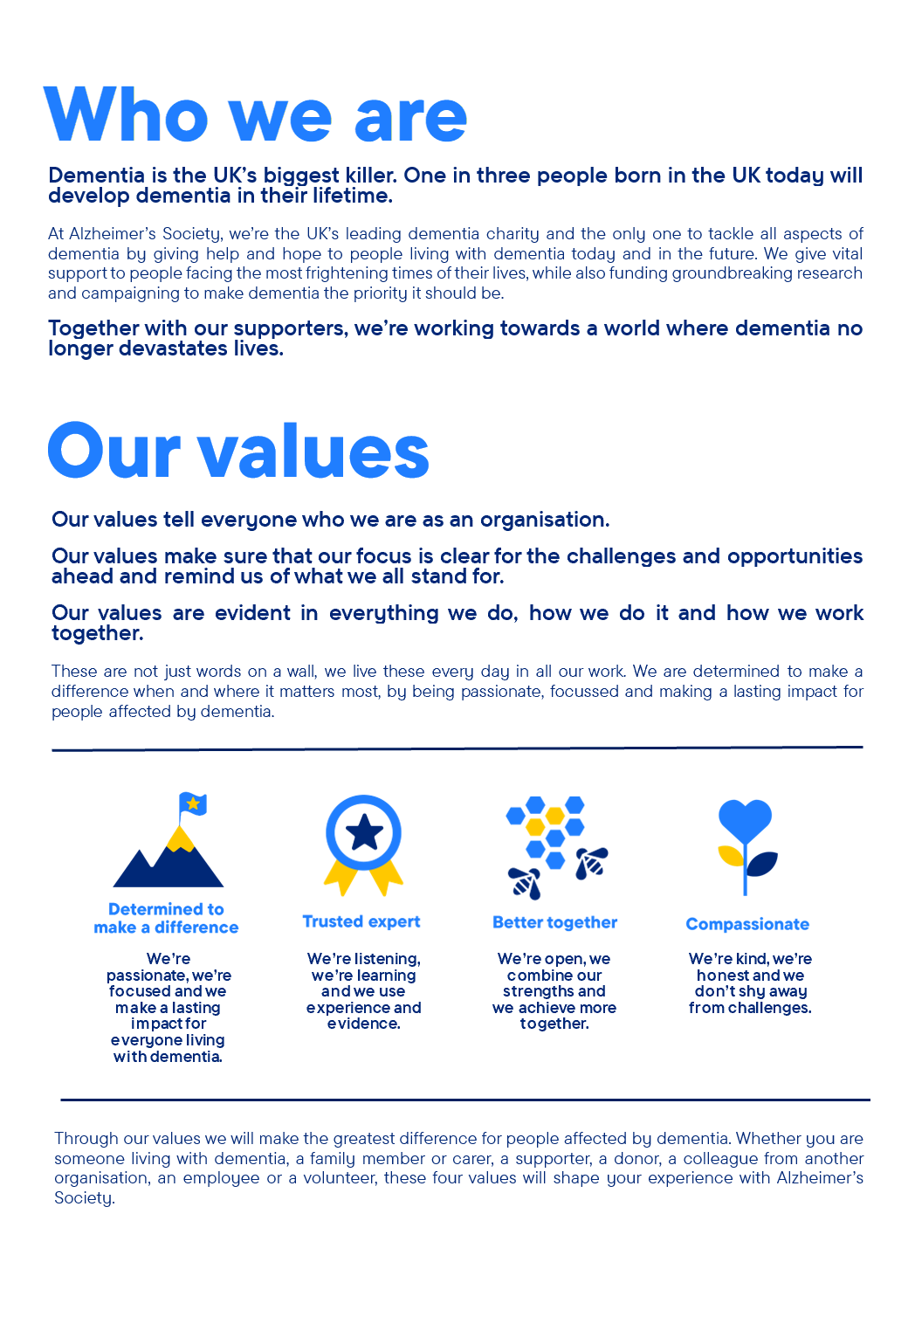

Research Grants Assistant

Position in the organisation
Reports to the Senior Research Grants Officer
Member of our Research Grants team within the Research and Innovation department
Part of our Research and Influencing Directorate

Purpose of this role
At Alzheimer’s Society, we are committed to ending the devastation caused by dementia. Achieving this future relies on bold, ambitious research - which is why today we are funding over £50 million in world‑leading dementia research and support a network of more than 400 researchers across the UK. Our pioneering research programme drives innovation, empowers leading scientists, and ensures that people affected by dementia shape the questions we ask and the breakthroughs we pursue. Together, we are tackling the biggest challenges in dementia so that everyone can access the diagnosis, treatments, care and support they deserve.
The Research team plays a central role in delivering this ambition. We ensure that every project we fund is of the highest quality and aligned with the Society’s strategy. Passionate, evidence‑driven and solutions‑focused, we work collaboratively across the organisation to strengthen the UK dementia research ecosystem, accelerate scientific understanding and create equitable pathways from discovery to impact - ensuring research leads to real-world benefit for all those affected by dementia.
As in‑house experts, we champion research at every stage. We make complex science accessible, engaging and meaningful, ensuring breakthroughs are widely understood and effectively communicated. By translating evidence into inspiring stories, we position Alzheimer’s Society as a trusted leader in dementia research and motivate more people to join us in driving change.
We are looking for someone who is passionate about working with researchers and helping to deliver high-quality research. Your role is key in helping us deliver Alzheimer’s Society’s Research strategy and in supporting our mission to improve the lives of people affected by dementia through research.

The Research Grants Assistant will support the Research Grants team in delivering Alzheimer’s Society’s research funding program. Your role will have a particular focus on supporting the administration of funding rounds, including coordinating key meetings with external stakeholders, maintaining internal records and managing information within our grants systems. You will also help coordinate team activity and respond to enquiries from a range of stakeholders across the organisation and wider research community. Key to the success of this role will be close, integrated working to support the whole Research and Influencing department, working alongside teams such as Research Communications, Finance and Fundraising to support the effective delivery of our research funding activities.

You will be line managed by the Senior Research Grants Officer and have the opportunity to learn and develop your knowledge of research funding and the wider research landscape, working in a function that benefits from working closely with teams across the organisation while engaging with leading dementia researchers and contributing to the support and delivery of high-quality research.

This is a varied role that plays an important part in supporting the delivery of Alzheimer’s Society’s research funding programme. You will support the full research funding lifecycle, from application and expert review processes, through to supporting funded projects and wider team priorities. You will work with a range of stakeholders including researchers, volunteers and colleagues across the organisation, helping to ensure a smooth and well-supported experience throughout. This will include supporting invoicing and monitoring of research grants, maintaining accurate systems and records and helping to co-ordinate meetings and events. You will also play a role in keeping the team organised and connected, supporting the tracking of research activity and contributing to improvements in how we work, to ensure information is clear and accessible.

You will develop and use your understanding of dementia research and the research community to prepare webinars and presentations to the research community interested in applying to the Society for funding. You will also have the confidence to represent Alzheimer’s Society at conferences and events, and support with coordinating the Research team’s presence at such events. You will support the daily administration of your team through tasks such as maintaining workload trackers, supporting with meeting minutes and circulating regular updates on team activity.

You will enjoy being part of a motivated team and helping us achieve shared objectives and goals.

We are looking for someone who exemplifies our values, someone who is: Determined to make a difference when and where it matters most. A trusted expert who believes in working Better together and demonstrates true Compassion.

Key accountabilities and responsibilities
- Monitor external environment developments and opportunities relevant to dementia research and research funding

- Respond to internal and external enquiries within criteria agreed by the Research Managers

- Support the coordination of research funding processes, from application and review through to management of funded projects

- Develop and maintain accurate records and data across applications, funded projects and stakeholder information within team databases and systems

- Support preparation of materials, logistics, evaluation for research funding meetings and activities

- Plan, organise and deliver a range of engagements, events and meetings as appropriate, including our presence at conferences.

- Provide support to the Research Grants Officers

- Working collaboratively with other Assistants across Research to deliver first class whole-team support.
- Ability and willingness to travel independently on behalf of the Society, including occasional overnight stays as required.
We are looking for someone who can…
- Adhere to all the Society’s service standards, policies and procedures.
- Comply with the data protection regulations, ensuring that information on clients remains confidential.
- Be responsible for personal learning and development, to support the learning and development of others and the whole organisation.
- Work in a manner that facilitates inclusion, particularly of people with dementia.
- Implement the Society’s health and safety policy and procedures, ensuring that all practices and procedures are undertaken in accordance with a healthy and safe working environment and that all staff and volunteers for whom you may be responsible are aware of their responsibilities in respect of their role, monitoring data and recommending action as required.
- Administrate and organise own work to ensure that it is accurate and meets quality targets, reasonable deadlines, and reporting requirements.
Person specification and selection criteria
Skills & Knowledge | Application (A) or Interview (I)
Experience of working in the science, health or policy sectors | A/I
Experience of working with databases or information management systems | A/I
Ability to present complex information in accessible and understandable ways | A/I
Excellent oral and written communication skills | A/I
Able to work across teams to deliver complex projects | A/I
Strong IT skills | A/I
Able to create and manage database information for different purposes | A/I
Proven experience in organising internal and external engagement events | A/I

Competencies & Personal Attributes | Application (A) or Interview (I)
Be a team player, supporting colleagues when there are deadlines, and know when to ask for help themselves. | A/I
Be a self-starter and incredibly motivated. | A/I
Excellent organisational and timekeeping skills. | A/I
Excellent attention to detail. | A/I
Non-judgemental communication, tolerant and welcoming of differences of perspective and opinion | A/I
Commitment to and understanding of equal opportunities | A/I
Understanding of the inclusion agenda and its relevance within a diverse society | A/I
Curious and constantly questioning the status quo | A/I
Eager and able to work at pace in a complex environment | A/I
Independently minded and a critical thinker | A/I
Flexible, creative and committed to continuous improvement | A/I
Able to adapt to situations, people and challenges | A/I
Pragmatic individual who is ambitious for themselves and others | A/I

Follow us on Twitter and Instagram @Alzheimerssoc and Like us on Facebook or check out Alzheimer’s Society YouTube channel youtube.com/AlzheimersSociety
Criminal Record Check
This post may be subject to a satisfactory Criminal Records Check, from either the Disclosure and Barring Service (England & Wales), Disclosure Scotland Check (Scotland) or AccessNI (Northern Ireland). Please select the level of Check required for this role:
Basic ☐
Enhanced ☐
Not Applicable ☒
Candidates - If you require further information regarding Criminal Records Check, then please contact: careers@alzheimers.org.uk
Hiring Managers - If you require further information regarding Criminal Records Check for this role, then please contact: Employeesupport@alzheimers.org.ukants
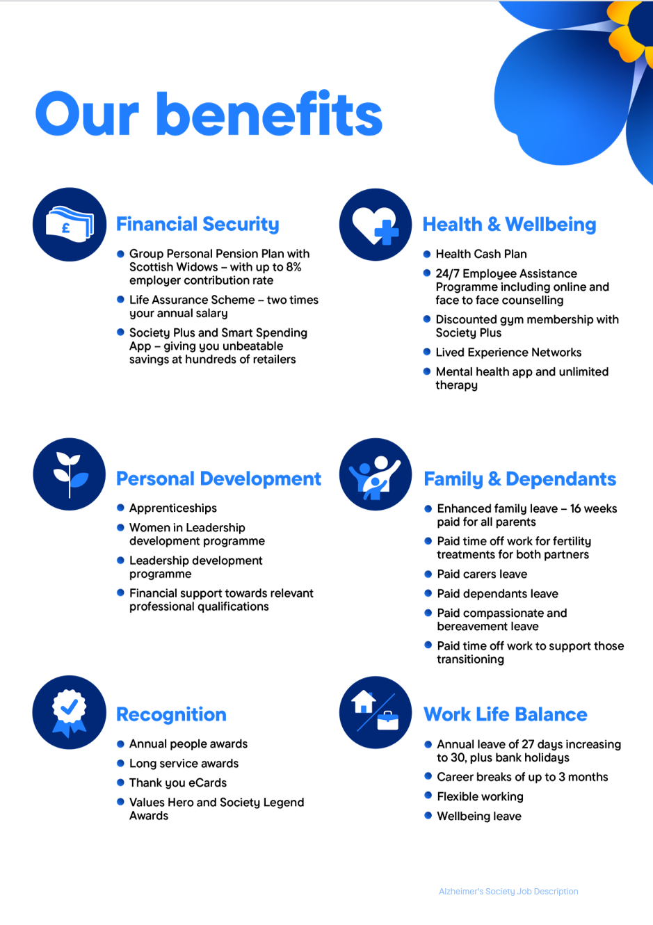
https://www.alzheimer

