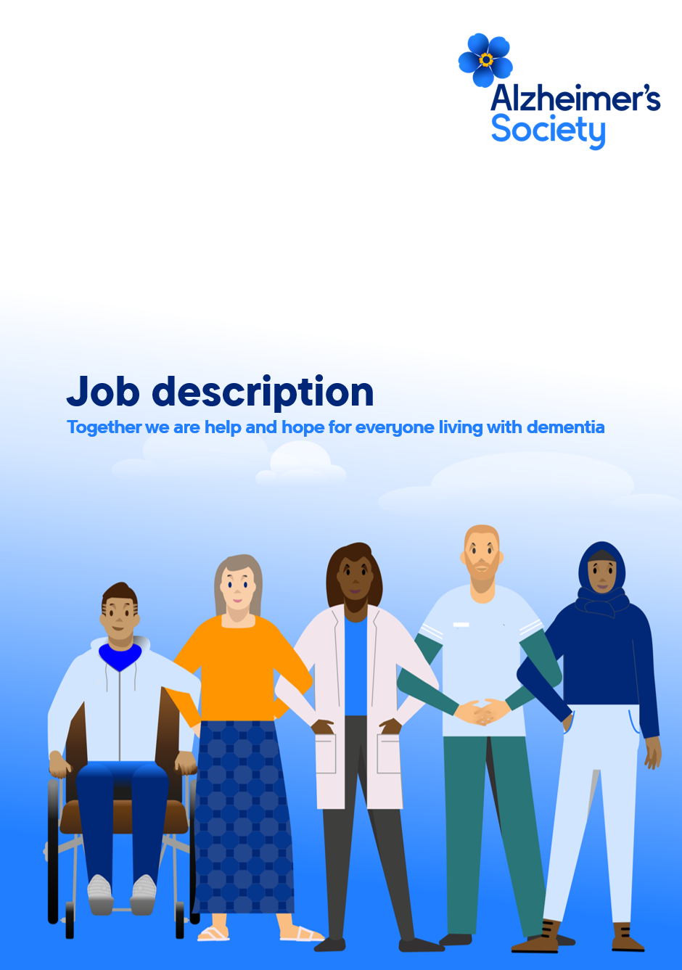

Research Communications Assistant

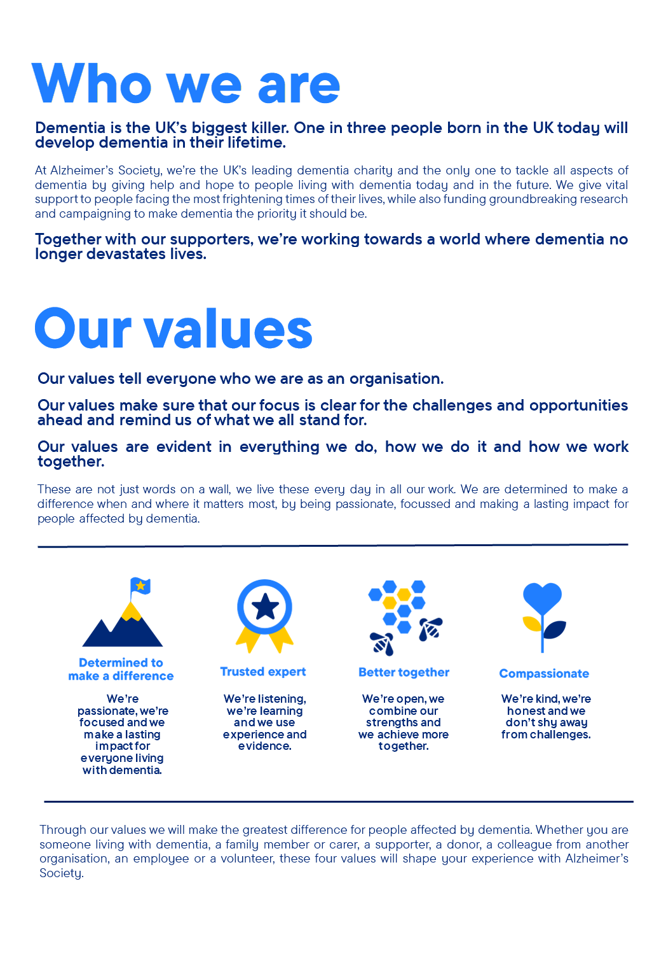

Research Commmunications Assistant

Position in the organisation
Reports to the Research Information Manager
Member of our Research Communications team within the Research and Innovation department
Part of our Research and Influencing Directorate

Purpose of this role
At Alzheimer’s Society, we are committed to ending the devastation caused by dementia. Achieving this future relies on bold, ambitious research - which is why today we are funding over £50 million in world‑leading dementia research and support a network of more than 400 researchers across the UK. Our pioneering research programme drives innovation, empowers leading scientists, and ensures that people affected by dementia shape the questions we ask and the breakthroughs we pursue. Together, we are tackling the biggest challenges in dementia so that everyone can access the diagnosis, treatments, care and support they deserve.
The Research team plays a central role in delivering this ambition. We ensure that every project we fund is of the highest quality and aligned with the Society’s strategy. Passionate, evidence‑driven and solutions‑focused, we work collaboratively across the organisation to strengthen the UK dementia research ecosystem, accelerate scientific understanding and create equitable pathways from discovery to impact - ensuring research leads to real-world benefit for all those affected by dementia.
As in‑house experts, we champion research at every stage. We make complex science accessible, engaging and meaningful, ensuring breakthroughs are widely understood and effectively communicated. By translating evidence into inspiring stories, we position Alzheimer’s Society as a trusted leader in dementia research and motivate more people to join us in driving change.
We are looking for someone who is passionate about communicating science in an engaging way to a range of audiences. Your role is key in helping us deliver Alzheimer’s Society’s Research strategy and in supporting our mission to improve the lives of people affected by dementia through research.

The Research Communications Assistant will support the Research Communications team to ensure that complex research is shared effectively. This will include responding to enquiries from internal and external audiences, supporting the development of content for various channels and representing Alzheimer’s Society at external events. High levels of organisation and excellent attention to detail will also help you to maintain the workload tracker used across the team, facilitating forward planning. Key to the success of this role will be close, integrated working to support the whole Research and Influencing department, working particularly closely with the Research Grants team to ensure Grants and Communications activity is complementary.

You will be line managed by the Research Information Manager and have the opportunity to learn and develop your knowledge of research communications working in a function that benefits from close relationships with teams across the organisation, including income and engagement, media, social media, internal communications and more.

This diverse role provides an opportunity to be involved in activity across the wider Research Communications team to ensure our communications reach key audiences. The methods you could use to reach these audiences include web content, social media, press, events and video content. You will also support with tracking activity across the team minimising duplication and helping to maximise use of assets and resources.

You will be able to use your understanding of our work and the wider dementia research field to prepare briefings, reports and other creative assets. You will also have the confidence to represent Alzheimer’s Society at conferences and events, and support with coordinating our presence at such events. You will support the daily administration of your team including through tasks such as maintaining workload trackers, supporting with meeting minutes and circulating regular updates on team activity.

You will enjoy being part of a motivated team and helping us achieve shared objectives and goals.

We are looking for someone who exemplifies our values, someone who is: Determined to make a difference when and where it matters most. A trusted expert who believes in working Better together and demonstrates true Compassion.

Key accountabilities and responsibilities
- Monitor the external environment developments and opportunities relevant to dementia research and share with the research team

- Maintain and build a sound knowledge base of Alzheimer’s Society research and the wider research environment related to dementia, asking clarifying questions if needed.

- Respond to internal and external enquiries within criteria agreed by the Research Managers - including by monitoring our research enquiries inbox and responding to reactive media enquiries.

- Support the Research Information Officer to manage a repository of research information for colleagues in income and engagement, regularly collecting feedback on resources and developing ideas to promote the resource hub internally.
- Support collaborative cross-organisation efforts to maintain research restrictions in accordance with the requirements of our finance teams and in line with donor intention.

- Prepare briefing and presentation materials for Research team colleagues.

- Plan, organise and deliver a range of engagements, events and meetings as appropriate, including the Research teams’ presence at conferences, donor stewardship events, lab visits and research talks.

- Liaise with researchers to request quotes, headshots, speaking availability and other assets.

- Support with research-related web and social content creation and maintenance.
- Work collaboratively with the wider Research Communications team to support the delivery of integrated communications plans around key activity from our own research portfolio and activity from the wider dementia research field.

- Provide support to the Research Communications Officers

- Commit to open communication of workload and ability to deliver, to support efficient working across the team

- Working collaboratively with other Assistants across Research to deliver first class whole-team support.
- Ability and willingness to travel independently on behalf of the Society, including occasional overnight stays as required.

- Undertake any other reasonable duties which may arise from time to time and which are commensurate with the general level of the post.

We are looking for someone who can…
- Adhere to all the Society’s service standards, policies and procedures.
- Comply with the data protection regulations, ensuring that information on clients remains confidential.
- Be responsible for personal learning and development, to support the learning and development of others and the whole organisation.
- Work in a manner that facilitates inclusion, particularly of people with dementia.
- Implement the Society’s health and safety policy and procedures, ensuring that all practices and procedures are undertaken in accordance with a healthy and safe working environment and that all staff and volunteers for whom you may be responsible are aware of their responsibilities in respect of their role, monitoring data and recommending action as required.

- Administrate and organise own work to ensure that it is accurate and meets quality targets, reasonable deadlines, and reporting requirements.

Person specification and selection criteria

Skills & Knowledge | Application (A) or Interview (I)
Experience of working in the science, health or policy sectors | A/I
Experience of working in a fast-paced communications team | A/I
Ability to present complex information in a variety of accessible and understandable ways | A/I
Excellent oral and written communication skills | A/I
Able to work across teams to deliver complex projects | A/I
Strong IT skills | A/I
Able to create and manage database information for different purposes | A/I
Proven experience in organising internal and external engagement events | A/I

Competencies & personal attributes | Application (A) or interview (I)
Be a team player, supporting colleagues when there are deadlines, and know when to ask for help themselves. | A/I
Be a self-starter and incredibly motivated. | A/I
Excellent organisational and timekeeping skills. | A/I
Excellent attention to detail. | A/I
Non-judgemental communication, tolerant and welcoming of differences of perspective and opinion | A/I
Commitment to and understanding of equal opportunities | A/I
Understanding of the inclusion agenda and its relevance within a diverse society | A/I
Curious and constantly questioning the status quo | A/I
Eager and able to work at pace in a complex environment | A/I
Independently minded and a critical thinker | A/I
Flexible, creative and committed to continuous improvement | A/I
Able to adapt to situations, people and challenges | A/I
Pragmatic individual who is ambitious for themselves and others | A/I

Follow us on Twitter and Instagram @Alzheimerssoc and Like us on Facebook or check out Alzheimer’s Society YouTube channel youtube.com/AlzheimersSociety
Criminal Record Check
This post may be subject to a satisfactory Criminal Records Check, from either the Disclosure and Barring Service (England & Wales), Disclosure Scotland Check (Scotland) or AccessNI (Northern Ireland). Please select the level of Check required for this role:
Basic ☐
Enhanced ☐
Not Applicable ☒
Candidates - If you require further information regarding Criminal Records Check, then please contact: careers@alzheimers.org.uk
Hiring Managers - If you require further information regarding Criminal Records Check for this role, then please contact: Employeesupport@alzheimers.org.uk

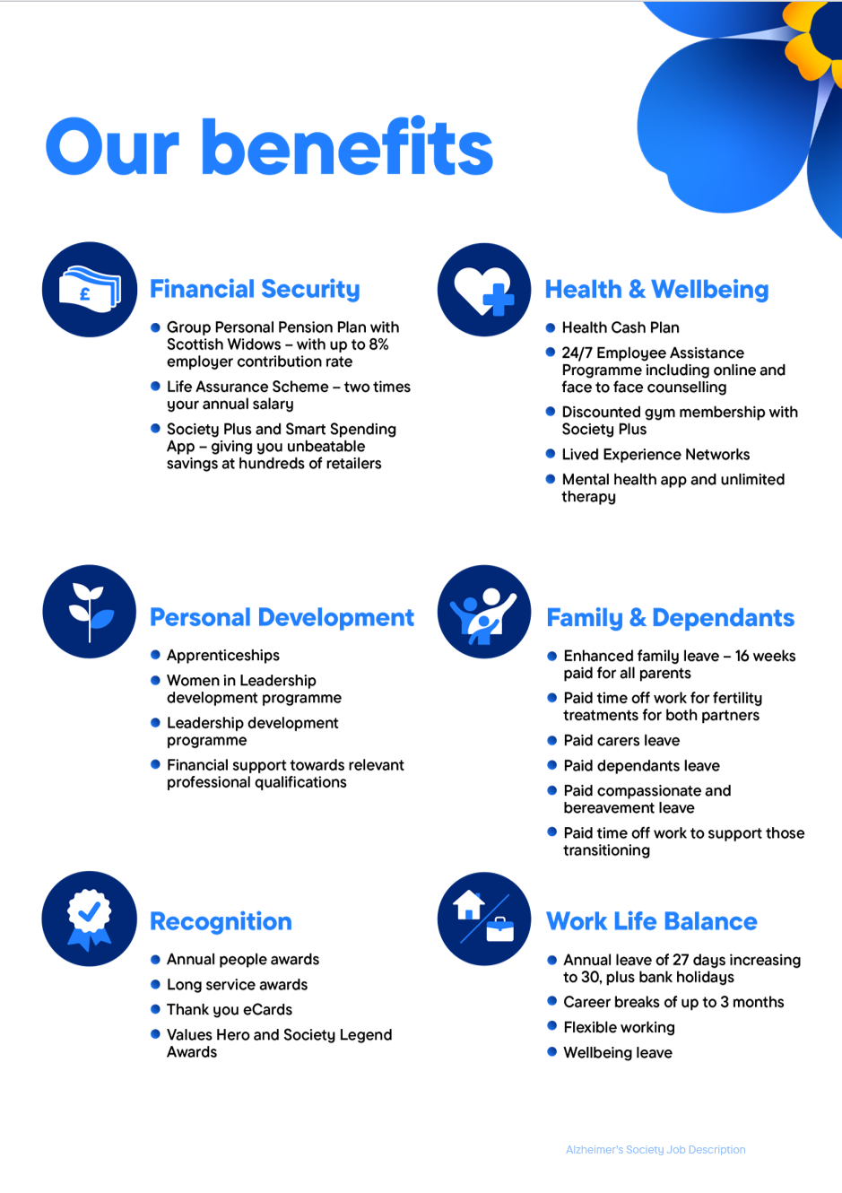
https://www.alzheimer

