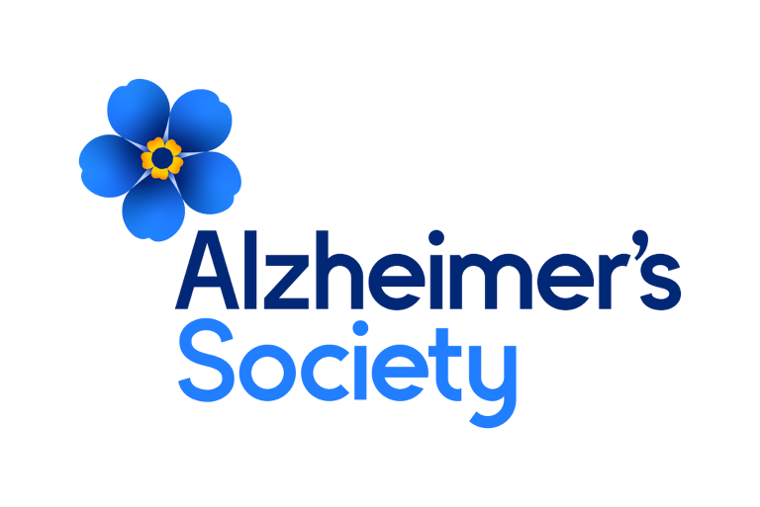
Assistant Legacy Case Officer


It will take a society to beat dementia. Alzheimer’s Society.
Job description

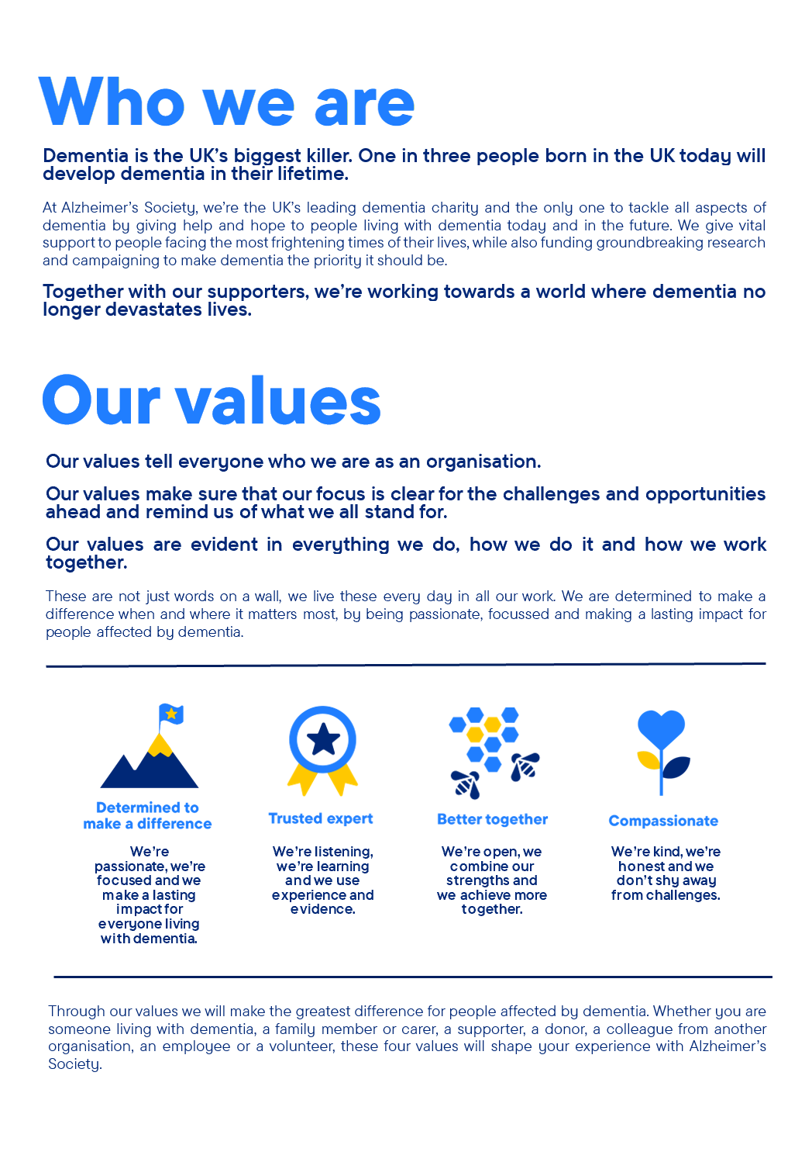

Assistant Legacy Case Officer

Position in the organisation
Reports to the Senior Legacy Case Manager.
Member of our Legacy Administration team.
Part of our Income and Engagement directorate.

Purpose of this role
At Alzheimer’s Society we are advisors, supporters, fundraisers, researchers, influencers, communicators, technical specialist and so much more. We are volunteers, we are employees, and together we are here to make a difference to the lives of people with dementia and their carers.

You will be responsible for managing a caseload of approximately 300 pecuniary and specific legacies, ensuring timely receipt of income and accurate record-keeping. You will deliver excellent customer care throughout, building and maintaining professional relationships with solicitors and lay executors. The role focuses on maintaining cash flow and maximising income through effective and responsible case management, contributing to the overall legacy income target of over £50m.
We are looking for someone who exemplifies our values, someone who is: Determined to make a difference when and where it matters most. A trusted expert who believes in working Better together and demonstrates true Compassion.

Key accountabilities and responsibilities
- You will manage a diverse caseload of pecuniary and specific legacies, with the opportunity to learn residuary and trust legacies.
- You will correspond professionally and sensitively with personal representatives, professional advisers, charity co-beneficiaries, and other stakeholders to resolve legacy cases effectively.
- You will have or aspire to work towards a recognised professional legacy qualification including Certificate in Charity Legacy Administration (CiCLA) or other relevant legal qualification.
- To play a crucial role in increasing legacy awareness by building relationships with key legacy stakeholders.
- To work alongside the Senior Legacy Case Manager, Senior Legacy Case Officer, Legacy Case Officers and Legacy Administrator.
- Ensure all legal requirements are met when progressing legacy case files.
- Correspond with Solicitors, Executors and family in a timely and professional manner.
- Liaise with other charities where necessary.
- Provide receipts for income and discharge to executors, within limits of authority.
- To undertake any other legacy related duties or projects when required.
- Provide support to the Legacy Case Administrator, when required.

We are looking for someone who can…
- Adhere to all the Society’s service standards, policies and procedures.
- Comply with the data protection regulations, ensuring that information on clients remains confidential.
- Be responsible for personal learning and development, to support the learning and development of others and the whole organisation.
- Work in a manner that facilitates inclusion, particularly of people with dementia.
- Implement the Society’s health and safety policy and procedures, ensuring that all practices and procedures are undertaken in accordance with a healthy and safe working environment and that all staff and volunteers for whom you may be responsible are aware of their responsibilities in respect of their role, monitoring data and recommending action as required.
- Administrate and organise own work to ensure that it is accurate and meets quality targets, reasonable deadlines, and reporting requirements.
- Follow the Society’s management information guidelines and requirements, including ensuring appropriate monthly measures on service usage levels are collected and submitted on the services database or other systems in accordance with deadlines.

Person specification and selection criteria
Skills & knowledge | Application (A) or Interview (I)
Experience in Legacy Administration and the use of First Class 4 preferred | A/I
Knowledge of Wills, Probate and Trust law preferred | A/I
ILM Certificate in Charity Legacy Administration or working towards preferred | A/I
Experience of working in a busy administrative function | A/I
Experience of working independently with minimal supervision | A/I
Experience of using Microsoft Office including Outlook and Excell | A/I
Experience of financial controls | A/I
Experience of working within a customer relations environment | A/I

Competencies & personal attributes | Application (A) or interview (I)
Be a team player, supporting colleagues when there are deadlines, and who knows when to ask for help themselves. | A/I
Be a self-starter and incredibly motivated. | A/I
Excellent organisational and timekeeping skills. | A/I
Excellent attention to detail. | A/I
Non-judgemental communication | A/I
Commitment to and understanding of equal opportunities | A/I
Understanding of the inclusion agenda and its relevance within a diverse society | A/I

Follow us on Twitter and Instagram @Alzheimerssoc and Like us on Facebook or check out Alzheimer’s Society YouTube channel youtube.com/AlzheimersSociety
Criminal Record Check
This post may be subject to a satisfactory Criminal Records Check, from either the Disclosure and Barring Service (England & Wales), Disclosure Scotland Check (Scotland) or AccessNI (Northern Ireland). Please select the level of Check required for this role:
Basic ☐
Enhanced ☐
Not Applicable ☒
Candidates - If you require further information regarding Criminal Records Check, then please contact: careers@alzheimers.org.uk
Hiring Managers - If you require further information regarding Criminal Records Check for this role, then please contact: Employeesupport@alzheimers.org.uk


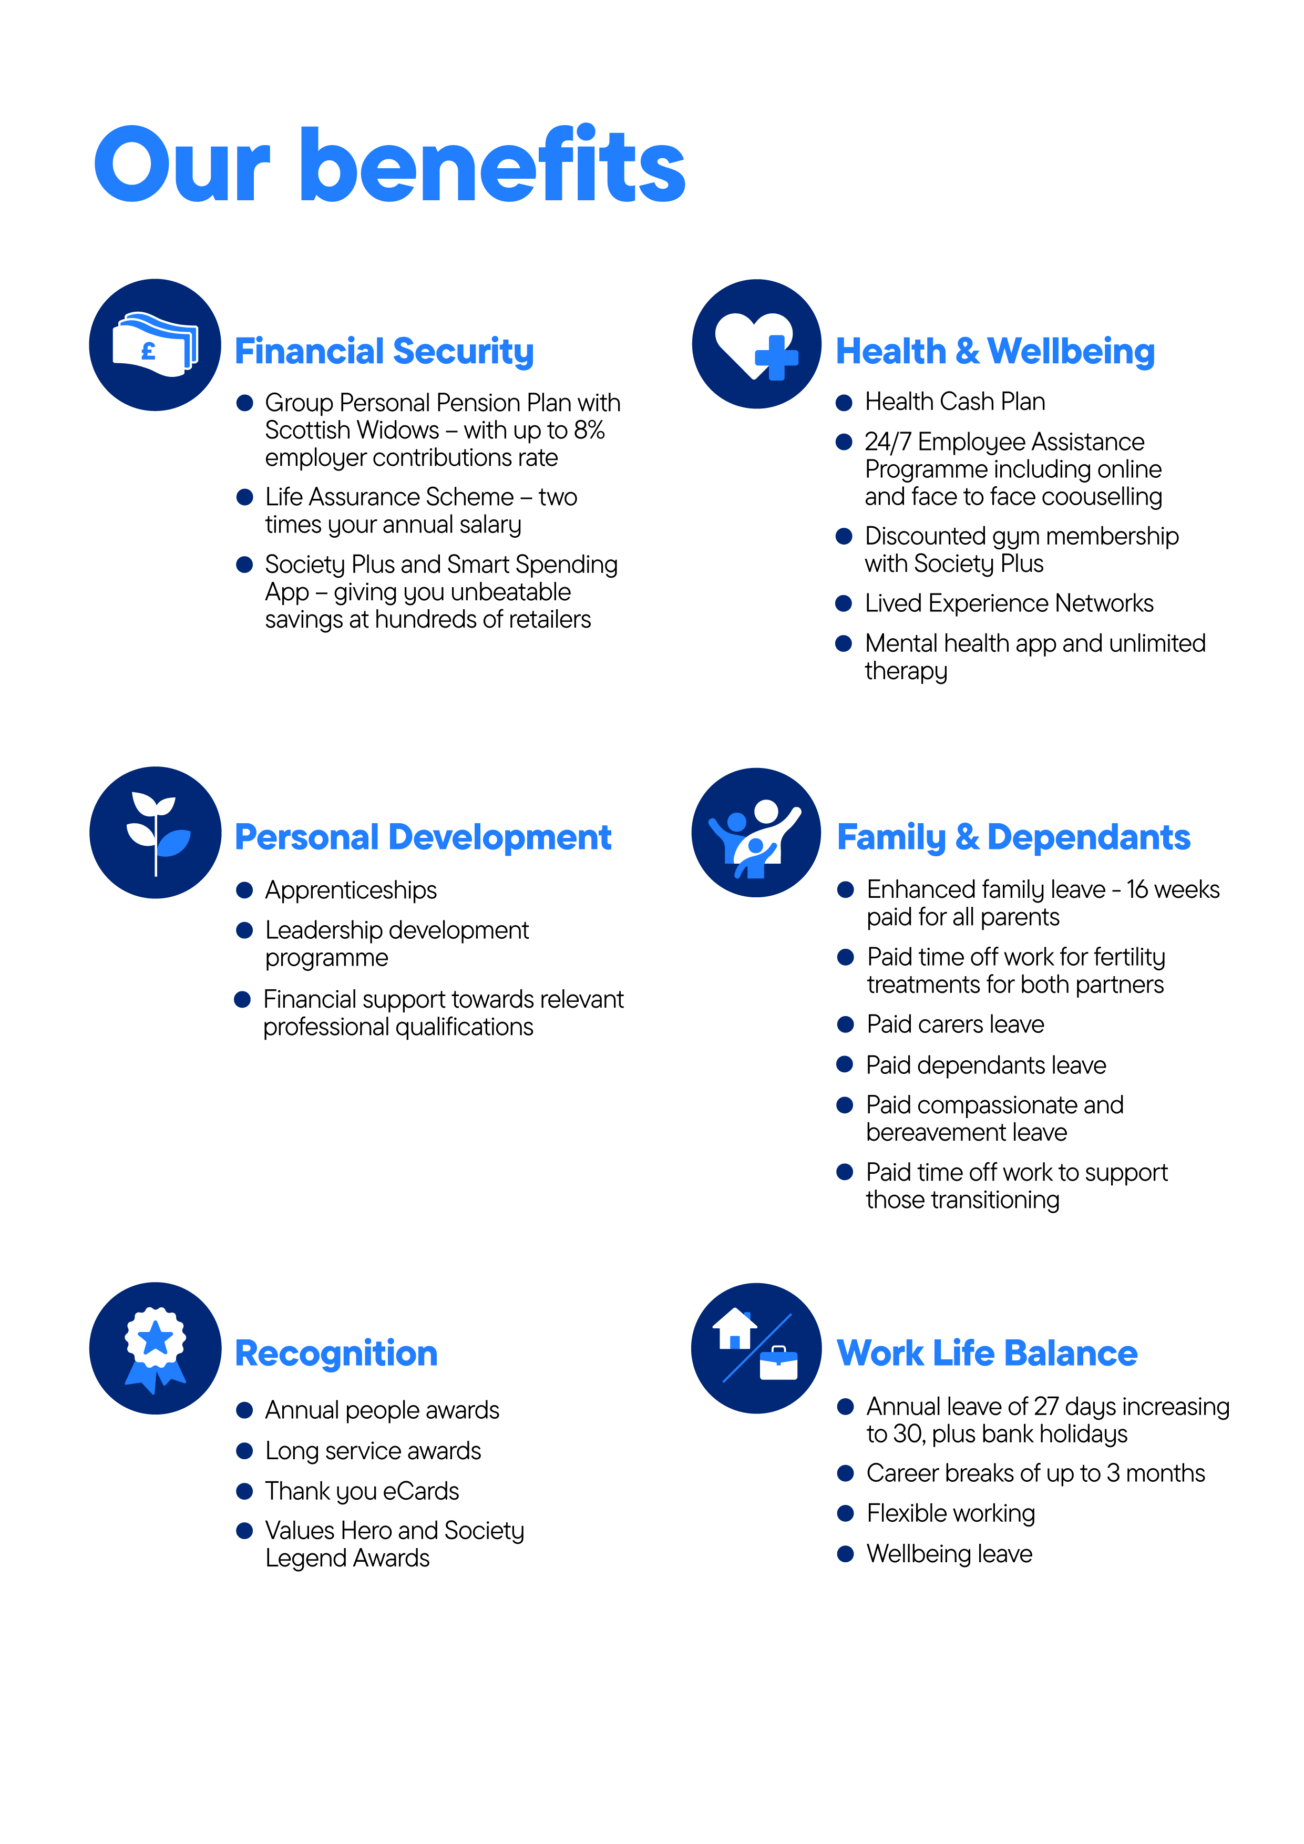
https://www.alzheimers.org.uk/sites/default/files/2024-08/alzheimers-society-how-to-talk-about-dementia-media-guide.pdf

