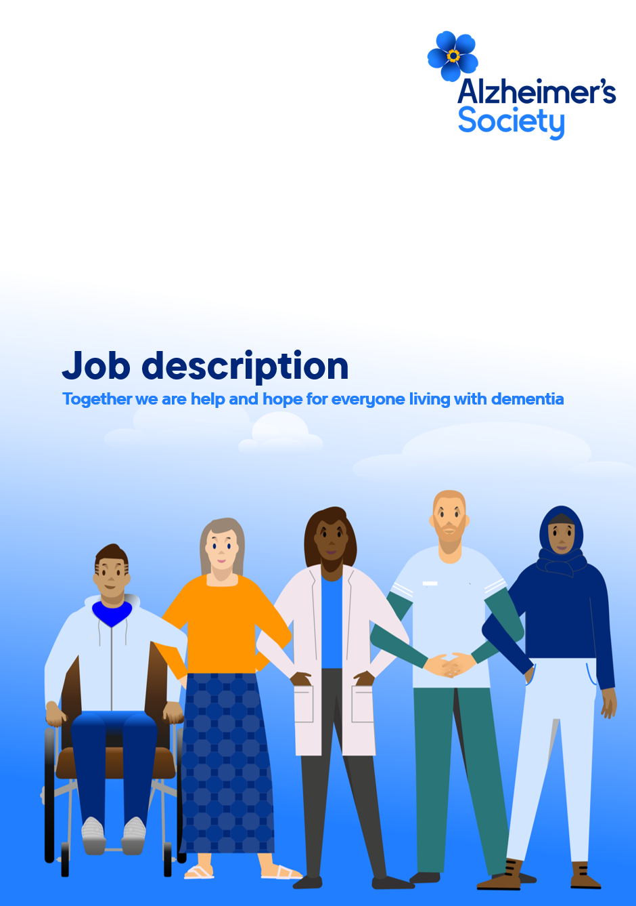

Research Grants Officer

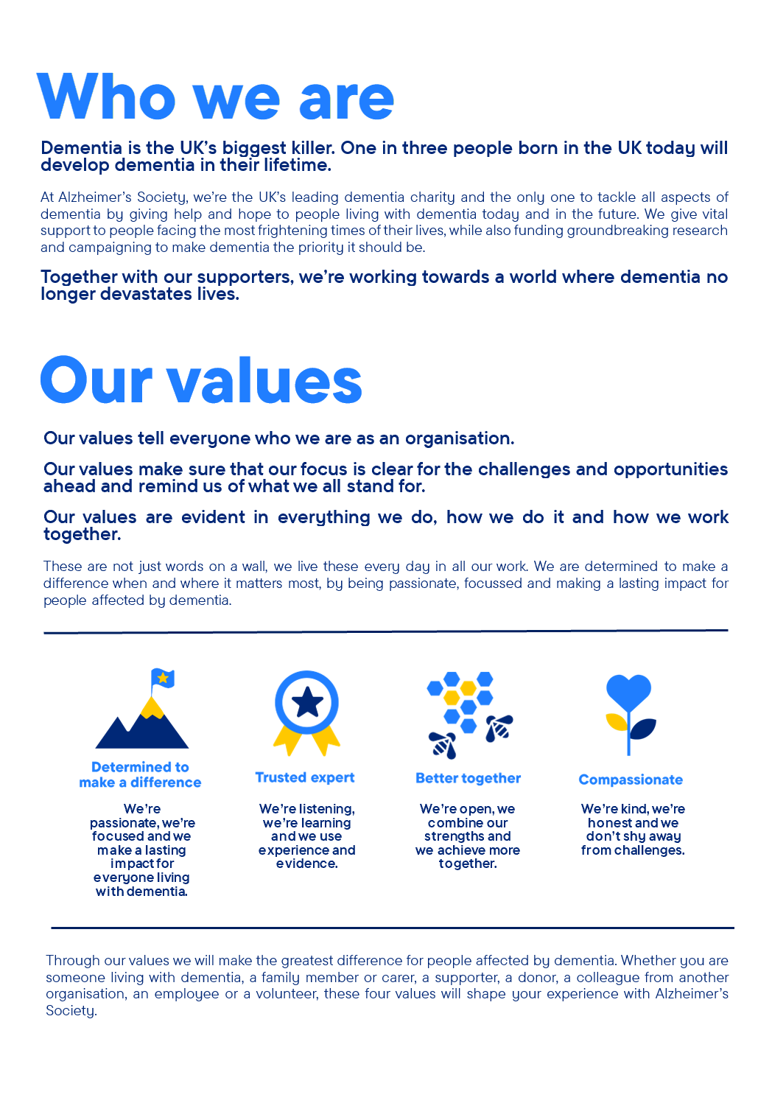

Research Grants Officer

Position in the organisation
Reports to the Research Grants Manager.
Member of our Research Team.
Part of our Research and Influencing directorate.

Purpose of this role
At Alzheimer’s Society we are advisors, supporters, fundraisers, researchers, influencers, communicators, technical specialist and so much more. We are volunteers, we are employees, and together we are here to make a difference to the lives of people with dementia and their carers.

We are looking for someone who exemplifies our values, someone who is: Determined to make a difference when and where it matters most. A trusted expert who believes in working Better together and demonstrates true Compassion.

Key accountabilities and responsibilities
- Day-to-day management of grant funding competitions and active grants portfolio, reporting to the Research Grants Manager.
- Responsibility for ensuring that the Society receives high quality peer review advice to inform research funding decisions.
- Contributing to the continual development of the research programme to improve its efficiency, for instance through implementing and evaluating changes to the application process and active grant management.

Other tasks
Grants management
- Management of grant applications.
- Providing a professional contact service by email, phone or in person to potential applicants to ensure that the Society receives high quality grant applications.
- Processing applications through the selection process via the online grants platform.
- Being responsible for ensuring the Society receives high quality independent peer review advice to use in making funding decisions.
- Management of lay review by Research Network volunteers.
- Preparing papers and other particulars for selection panel meetings.
- Attending selection panels and drafting minutes.
- Informing applicants of outcomes.

Management of funding awards
- Preparing contracts for awards.
- Working with Research Information Manager and fundraising colleagues to understand requirements for progress reporting, and ensuring these are adhered to.

Other grants management tasks
- Updating and developing information on the website aimed at potential applicants.
- Day to day management of the dedicated online grants database.
- Preparing reports and analyses on trends in the grant funding programme which will in turn contribute to its strategic development.

Relationship management
- Responsible for building and developing a wide range of connections with all sectors of the dementia research community, from researchers at the start of their careers through to influential leaders in academia and senior clinicians.
- Influence members of the research community to advocate for and publicise Alzheimer’s Society’s research programme amongst peers.
- Ensure that researchers who provide their time to supporting the research programme (through peer review or providing other advice) have a positive experience and feel valued so as to provide their continued support.

Supporting and co-ordinating other activities of the Research and Influencing directorate
- Answering queries from the general public.
- Supporting the organisation and delivery of the Annual Conference and Early Career Researcher Retreat.
- Assisting with management of the Research Network volunteers and the hosting of public and patient involvement events.

Data collection and analysis
- Preparing reports and analyses on trends in the grant funding programme so as to contribute to the strategic development of the research programme.
- Preparing data and reports for external bodies, such as the Association of Medical Research Charities.
- Capturing publications and other outputs arising from funded research.

Other duties
- To be a representative of the Research and Influencing Directorate at conferences and stakeholder meetings.
- To work as a full member of the Research and Influencing Directorate and provide cover for other members of the team as required.
- To develop partnership opportunities with other organisations and charities that help to fulfil the strategic ambitions of the Research and Influencing Directorate.
- To undertake any other duties or projects commensurate with the nature and grade of this post as required.

We are looking for someone who can…
- Adhere to all the Society’s service standards, policies and procedures.
- Comply with the data protection regulations, ensuring that information on clients remains confidential.
- To champion the diverse needs of people affected by dementia by working in a manner that facilitates inclusion and collaboration, within and beyond the Society.
- To support and enable volunteering activities.
- To implement the Society’s health and safety policy and procedures, ensuring that all practices and procedures are undertaken in accordance with a healthy and safe working environment and that all staff and volunteers for whom you may be responsible are aware of their responsibilities in respect of their role, monitoring data and recommending action as required.
- To be responsible for personal learning and development, to support the learning and development of others and the whole organisation.
- To administrate and organise own work to ensure that it is accurate and meets quality targets, reasonable deadlines and reporting requirements.
- Work to embed a culture of inclusion and collaboration, within and beyond the Society.

Person specification and selection criteria
Skills & knowledge | Application (A) or Interview (I)
A relevant degree in a biomedical or health discipline or relevant experience | A/I
Proven experience of grants management, research administration or a similar role | A/I
Experience of managing and manipulating data sets | A/I
Knowledge of dementia, health research environment and research communities | A/I
Understanding of volunteer roles in charities | A/I
Knowledge of scientific search engines | A/I
Ability to develop working relationships with internal and external stakeholders, including senior researchers | A/I
Ability to present and lead discussions with smaller audiences | A/I
Ability to plan, prioritise and deliver to tight timescales | A/I
Understanding of the need for confidentiality | A/I

Competencies & personal attributes | Application (A) or interview (I)
Excellent communication skills, both verbal and written, enabling effective communication with a variety of different audiences | A/I
Work collaboratively and be able to prioritise your workload effectively and remain solution focused throughout | A/I
Strong interpersonal and interpretation skills which enable open jargon-free conversations with both internal and external stakeholders | A/I
Excellent organisational, administrative and timekeeping skills with excellent attention to detail with all tasks | A/I
Flexible approach to work | A/I
Willingness to work away from home, including occasional overnight travel | A/I
Understanding of the inclusion agenda and its relevance within a diverse society | A/I
Be a team player, supporting colleagues when there are deadlines and to develop new solutions | A/I
Incredibly self-motivated, with strong initiative and ability to work independently | A/I
Follow us on Twitter and Instagram @Alzheimerssoc and Like us on Facebook or check out Alzheimer’s Society YouTube channel youtube.com/AlzheimersSociety
Criminal Record Check
This post may be subject to a satisfactory Criminal Records Check, from either the Disclosure and Barring Service (England & Wales), Disclosure Scotland Check (Scotland) or AccessNI (Northern Ireland). Please select the level of Check required for this role:
Basic ☐
Enhanced ☐
Not Applicable ☒
Candidates - If you require further information regarding Criminal Records Check, then please contact: careers@alzheimers.org.uk
Hiring Managers - If you require further information regarding Criminal Records Check for this role, then please contact: Employeesupport@alzheimers.org.uk

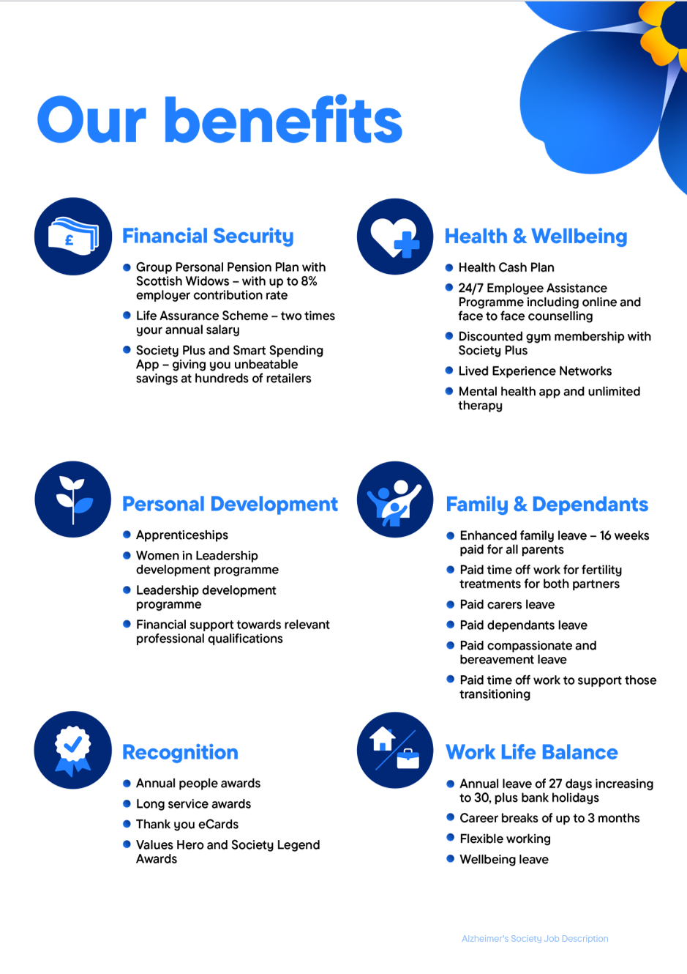
https://www.alzheimer

