
Regional Fundraiser

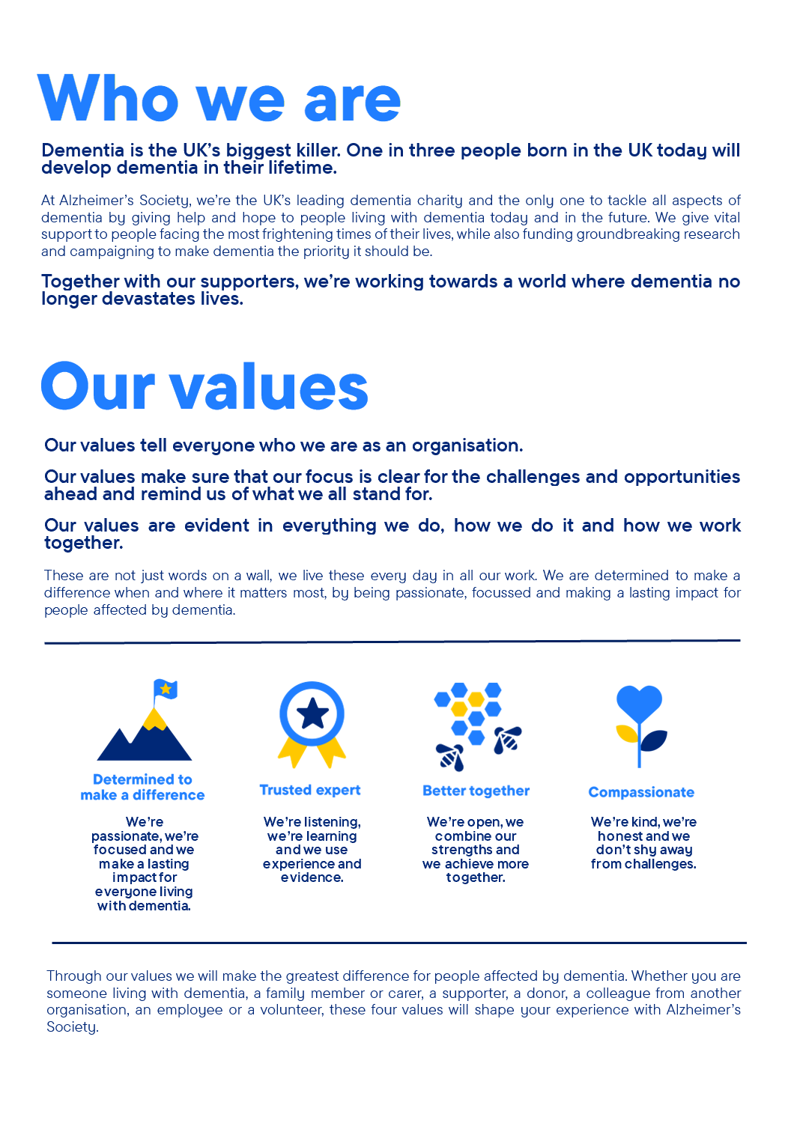

Regional Fundraiser – Surrey
Reports to the Regional Fundraising Manager
Member of the South East team within Regional Engagement
Part of the Regional Engagement Directorate
Purpose of this role
- At Alzheimer’s Society we are advisors, supporters, fundraisers, researchers, influencers, communicators, technical specialist and so much more. We are volunteers, we are employees, and together we are here to make a difference to the lives of people with dementia and their carers.
- At Alzheimer’s Society we are advisors, supporters, fundraisers, researchers, influencers, communicators, technical specialists and so much more. We are volunteers, we are employees, and together we are here to make a difference to the lives of people with dementia and their carers.
- As the main contact for regional fundraising within your geographical area (Surrey) you will represent and promote the work, vision and purpose of the Society locally whilst also promoting and supporting the wider work of the Regional Engagement team. As a Regional Fundraiser you are ‘the fundraising face’ of Alzheimer’s Society in your geographical area and will engage and inspire your supporters to raise funds and awareness for us. You need to be a trusted regional expert capable of building mutually beneficial relationships and work collaboratively to provide exceptional stewardship.
- Typically, you will be responsible for your own core counties to manage in your area. However, sometimes you will need to be flexible and ready to focus on other areas where funds are also raised. For example, you might need to help attract new supporters from different places or take care of existing supporters across various income streams in other areas. We will seek to maximise your skills effectively in your core counties; while also making sure they benefit the wider region needs. This way, we can make the biggest impact in fundraising for people affected by dementia.
Your role will focus on
- Maximising fundraising income from three core income streams within a geographical area (Surrey) – companies, organisations, groups, associations and individuals up to the value of £100k
- Relationship building– providing exceptional stewardship to build relationships that boost retention and lifetime value for our supporters.
- Acquisition & pipelining - driving new business income (from prospecting through to pitch development and delivery)
- We are looking for someone who exemplifies our values, someone who is:
- Determined to make a difference when and where it matters most. A trusted expert who believes in working Better together and demonstrates true Compassion.
Key accountabilities and responsibilities
- Grow income in a geographical area to exceed targets and deliver KPIs.
- Develop and deliver plans for local fundraising across three core income streams: providing exceptional stewardship to achieve financial targets.
- Support work needed across the region to deliver and exceed income targets.
- Recruit and manage volunteers in line with activity plan.
- Work proactively to identify and deliver new fundraising opportunities, through pipelining
- and winning new income Corporate, Groups and Associations, Individuals and Third-party activities to maximise income streams.
- Deliver excellent account management and stewardship appropriate to value and opportunity.
- A trusted expert with the knowledge of the geographical area needed to produce an activity plan to deliver and drive KPIs.
- Work with a budget to manage and deliver income, providing detailed commentary and insights to line manager on variances, capacity and trends at regular intervals agreed.
- Maintain effective relationships with colleagues and identify cross-departmental opportunities where appropriate by working collaboratively.
- Create and maintain mutually beneficial relationships with all supporters, maximizing retention and long-term value to the Society.
- To carry out reasonable duties as might be required which are commensurate with the nature of the post to meet the needs of the Directorate.
- Expectation to proactively seek opportunities to deliver face to face stewardship, acquisition and representing the society at events including working occasional evenings and weekends.
- Ability to travel across your patch regularly to deliver stewardship.
- Attend face to face departmental meetings and other events which may include overnight stays.
We are looking for someone who can…
Adhere to all the Society’s service standards, policies and procedures.
- Comply with the data protection regulations, ensuring that information on clients remains confidential.
- Champion the diverse needs of people affected by dementia by working in a manner that facilitates inclusion and collaboration, within and beyond the Society.
- Support and enable volunteering activities.
- Implement the Society’s health and safety policy and procedures, ensuring that all practices and procedures are undertaken in accordance with a healthy and safe working environment and that all staff and volunteers for whom you may be responsible are aware of their responsibilities in respect of their role, monitoring data and recommending action as required.
- Be responsible for personal learning and development, to support the learning and
- development of others and the whole organisation.
- Administrate and organise their own work to ensure that it is accurate and meets quality targets, reasonable deadlines and reporting requirements.
- Work to embed a culture of inclusion and collaboration, within and beyond the Society.

Person specification and selection criteria
Skills & knowledge | Application (A) or Interview (I)
Experience of relationship community fundraising or ability to demonstrate transferrable skills. | A/I
Good understanding of budgeting and financial management. | A/I
Experience of identifying and acquiring new business opportunities. | A/I
Experience of delivering excellent supporter stewardship and/or customer care. | A/I
Able to analyse data and information to make decisions. | A/I
Proven track record in achieving financial and non-financial targets. | A/I
Proven experience of excellent customer or account management. | A/I
Experience of working with volunteers. | A/I

Competencies & personal attributes | Application (A) or interview (I)
Be a team player, supporting colleagues when there are deadlines, and who knows when to ask for help themselves. | A/I
Be a self-starter and incredibly motivated. | A/I
Excellent organisational and timekeeping skills. | A/I
Excellent attention to detail. | A/I
Non-judgemental communication | A/I
Commitment to and understanding of equal opportunities | A/I
Understanding of the inclusion agenda and its relevance within a diverse society | A/I

Follow us on Twitter and Instagram @Alzheimerssoc and Like us on Facebook or check out Alzheimer’s Society YouTube channel youtube.com/AlzheimersSociety
Criminal Record Check
This post may be subject to a satisfactory Criminal Records Check, from either the Disclosure and Barring Service (England & Wales), Disclosure Scotland Check (Scotland) or AccessNI (Northern Ireland). Please select the level of Check required for this role:
Basic ☐
Enhanced ☐
Not Applicable ☐
Candidates - If you require further information regarding Criminal Records Check, then please contact: careers@alzheimers.org.uk
Hiring Managers - If you require further information regarding Criminal Records Check for this role, then please contact: Employeesupport@alzheimers.org.uk
