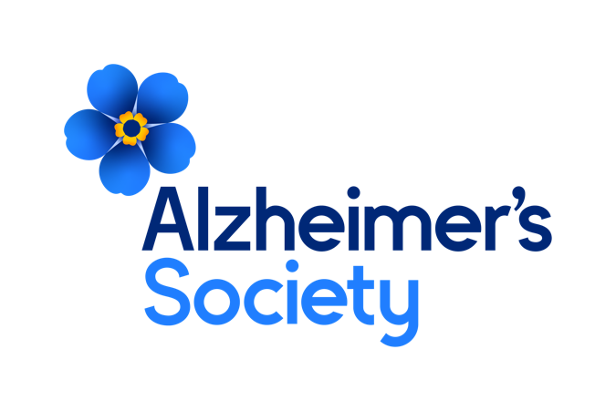

**Together we are help and hope for everyone living with dementia**

**Reporting Analyst**

**Job description**

**Who we are**

**Our values**

**Dementia is the biggest health and social challenge of our time.**

There are currently estimated to be 900,000 people in the UK with dementia. Many are undiagnosed and facing the realities of their condition alone.

At Alzheimer’s Society we’re working towards a world where dementia no longer devastates lives. We do this by giving help to those living with dementia today and providing hope for the future.

We’re here for everyone living with dementia.

As a Society, we are made up of people with dementia, carers, trusted experts, campaigners, researchers and clinicians. We are the UK’s largest collective force of people with unparalleled knowledge and over 40 years of experience addressing the biggest challenges facing people living with dementia.

**Together we are help and hope for everyone living with dementia.**

Our values tell everyone who we are as an organisation. Our values make sure that our focus is clear for the challenges and opportunities ahead and remind us what we all stand for. Our values are evident in everything we do, how we do it and how we work together.

These are not just words on a wall, we live these every day in all our work. We are Determined to make a difference when and where it matters most, by being passionate, focussed and making a lasting impact for people affected by dementia.



**We’re passionate, we’re focused and we make a lasting impact for everyone living with dementia.**



**We’re listening, we’re learning and we use experience and evidence.**



**We’re open, we combine our strengths and we achieve more together.**



**We’re kind, we’re honest and we don’t shy away from challenges.**

Through our values we will make the greatest difference for people affected by dementia. Whether you are someone living with dementia, a family member or carer, a supporter, a donor, a colleague from another organisation, an employee or a volunteer, these four values will shape your experience with Alzheimer’s Society.

**Position in the Organisation**

**Reporting Analyst**

Reports to the Services Data Manager.  
Member of our Services Data team.  
Part of our Technology directorate.

Works with colleagues at all levels across multiple directorates, sharing knowledge and reporting expertise to enable more self - sufficiency and business intelligence.

Works in collaboration with other technical teams in IT and Data on delivery of reporting.

**Purpose of this Role**

We are here for anyone affected by dementia to help them navigate some of the hardest and most frightening times of their lives.

We are advisors, supporters, fundraisers, researchers, influencers, communicators, technical specialist and so much more. We are volunteers, we are employees, and together we are here to make a difference to the lives of people living with dementia and their carers.

The Reporting Analyst will lead on the requirement gathering, design and creation of high-quality reports to meet the business reporting needs as well as assisting the organisation in ensuring data relating to our services is utilised to its maximum potential. The post will enable colleagues to identify, analyse and agree reporting requirements, validate and quality assure reports and build ad hoc reports and views to support users. The post holder will take a strategic approach to report development and will prioritise report requests to ensure that new reports have maximum impact for a wide group of users. The analyst will build enough business knowledge to advise users, deal with queries and produce guidance.

We are looking for someone who exemplifies our values, someone who is: **Determined to make a difference** when and where it matters most. **A Trusted Expert** who believes in working **Better Together** and demonstrates true **Compassion**.

**Key Accountabilities and Responsibilities**

* Responsible for spreading knowledge of how data is stored and used, implementing processes and reporting across the organisation within guidance from the Services Data Manager
* Responsible for ensuring that the standard suite of reports meets user needs and that an effective mechanism to deliver ad-hoc reporting is in place
* Responsible for proactively identifying new and emerging reporting requirements and developing these along with existing requirements into a comprehensive directory to support the business
* Responsible for identifying and implementing improvements to procedures relevant to the role and to maintain documentation accordingly.
* Liaise directly with suppliers and external agencies to agree data exchange standards, data transfers, reporting requirements and for support.

**Duties and key responsibilities**

**Strategy**

* To play a pivotal role for the implementation of the Data Strategy regarding reporting, insight and providing colleagues with a solid evidence base.
* Lead in developing strategy to fulfil the organisation’s database and reporting needs. E.g. by reviewing potential software solutions, creating reporting structures and designing reporting definition

**Reporting development and analysis**

* Lead on the development of a suite of sophisticated Business Intelligence and Management Information reports for business owners
* Leading user engagement to establish standard reporting requirements and translate these into robust specifications for development whilst prioritising requests where benefits can be maximised by a wide range of users.
* Respond to report queries from users, create ad-hoc reporting and provide advice and guidance.
* Demonstrate and prove the value of management reporting by creating prototypes, highlighting reportable KPIs and producing dashboards
* Write complex SQL scripts and use business intelligence software to manipulate and present large datasets into easy to digest reports and dashboards for management teams across the organisation
* Carry out business analysis to identify better or new ways to use data from all directorates within the Society
* Co-ordinate the testing of new reports and organise user acceptance testing

**Administration and support**

* Lead in the production and delivery of training for reporting as necessary
* Liaise with database software suppliers to ensure data systems and structures are working efficiently for organisational needs
* Identify on-going issues and difficulties with all forms of data and work with internal and external suppliers to diagnose and resolve as necessary
* Working with the Data Architect to define roadmap for data reporting definitions and standards
* Guide colleagues across the Society in maximising use of reporting with regard to record-keeping and analysis by providing guidance documentation.
* Work with the Solutions Analyst to create SQL data integrity scripts for regular house-keeping; ensuring data is accurate, complies with the Society’s business rules and Data Protection legislation
* Responsible for articulating the users’ needs of other teams and directorates by creating comprehensive requirements documents and advise on proper use of the database
* To undertake any other duties or projects commensurate with the nature and grade of this post as required.

**We are looking for someone who can…**

* Adhere to all the Society’s service standards, policies and procedures.
* Comply with the data protection regulations, ensuring that information on clients remains confidential.
* Be responsible for personal learning and development, to support the learning and development of others and the whole organisation.
* Work in a manner that facilitates inclusion, particularly of people with dementia.
* Implement the Society’s health and safety policy and procedures, ensuring that all practices and procedures are undertaken in accordance with a healthy and safe working environment and that all staff and volunteers for whom you may be responsible are aware of their responsibilities in respect of their role, monitoring data and recommending action as required.
* Administrate and organise own work to ensure that it is accurate and meets quality targets, reasonable deadlines, and reporting requirements.
* Follow the Society’s management information guidelines and requirements, including ensuring appropriate monthly measures on service usage levels are collected and submitted on the services database or other systems in accordance with deadlines.

**Person Specification and Selection Criteria**

|  |  |  |
| --- | --- | --- |
| **Skills & Knowledge** | **Essential (E) or Desirable (D)** | **Application (A) or Interview (I)** |
| Extensive experience of creating Business Intelligence and Management Information reports using SQL and/or proprietary reporting tools | E | A/I |
| Extensive experience of designing reports by co-creating requirements with users | E | A/I |
| Experience of implementing and supporting data processes | E | A/I |
| Experience of working with technical colleagues | E | A/I |
| Experience of performing businesses analysis on existing reporting landscapes and developing roadmaps | E | A/I |
| Experience of supporting large, multi-user datasets | E | A/I |
| Experience of working in a customer-facing environment | E | A/I |
| Experience of charity Services systems | D | A/I |
| Experience of working with Services data | D | A/I |
| Experience of technical change management methodology | E | A/I |
| Ability to independently identify issues and inefficiencies, and propose sound solutions | E | A/I |
| Ability to adapt report presentation and visualisation techniques according to the audience and function | E | A/I |
| Knowledge of SQL to an intermediate level | E | A/I |
| Experience of creating reports using a modern data visualisation tool e.g. Power BI or Tableau | E | A/I |
| Experience of writing detailed technical and non-technical documentation for a variety of users | E | A/I |
| Advanced Microsoft Office skills; in particular Excel, including data preparation and manipulation functions | E | A/I |
| Experience of working with Agile development or project management methodology | D | A/I |
| Excellent written and verbal communication skills | E | A/I |
| Able to work effectively on own initiative and as part of a team, without close supervision | E | A/I |
| Able to work to multiple deadlines and under pressure with a strong attention to detail | E | A/I |
| Ambitious, innovative, pro-active and target driven | E | A/I |
| Trustworthy, patient and a good relationship builder | E | A/I |
| Consistently striving for professional development | E | A/I |

|  |  |  |
| --- | --- | --- |
| **Competencies & Personal Attributes** | **Essential (E) or Desirable (D)** | **Application (A) or Interview (I)** |
| Be a team player, supporting colleagues when there are deadlines, and who knows when to ask for help themselves. | E | A/I |
| Be a self-starter and incredibly motivated. | E | A/I |
| Excellent organisational and timekeeping skills. | E | A/I |
| Excellent attention to detail. | E | A/I |
| Non-judgemental communication | E | A/I |
| Commitment to and understanding of equal opportunities | E | A/I |
| Understanding of the inclusion agenda and its relevance within a diverse society | E | A/I |

Essential requirements are those, without which, the post holder would not be able to fulfil the responsibilities of the role. Desirable requirements are those which would be useful for the post holder to possess and will be considered when more than one applicant meets the essential requirements.

This post will be subject to a satisfactory Criminal Records Check, from either the Disclosure and Barring Service (England & Wales), Disclosure Scotland Check (Scotland) or AccessNI (Northern Ireland). If you require further information regarding Criminal Records Check, then please contact: [careers@alzheimers.org.uk](mailto:careers@alzheimers.org.uk)

