
Head of Financial Partnering, Planning & Analysis

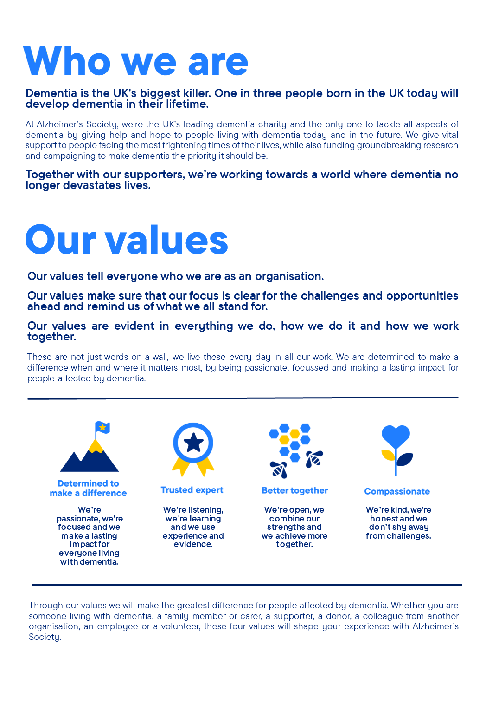

Head of Financial Partnering, Planning & Analysis

Position in the organisation
Reports to Associate Director, Finance.
Manages the Financial Partnering, Planning & Analysis Team.
Member of the Finance and Assurance Leadership Team.
Part of our Finance & Assurance directorate.

Purpose of this role
At Alzheimer’s Society we are advisors, supporters, fundraisers, researchers, influencers, communicators, technical specialist and so much more. We are volunteers, we are employees, and together we are here to make a difference to the lives of people with dementia and their carers.

In Finance & Assurance, our vision is to be the Society’s single point of truth. We are trusted partners, credible experts, working as one team to be a true enabler to the organisation as it makes impact to end the devastation of dementia.

Partnership, collaboration, accountability, professionalism and a restless desire to constantly improve are needed in every role across Finance & Assurance. That is true for the Head of Financial Partnering, Planning & Analysis, which works in partnership with all directorates and across the Finance function to deliver a truly collaborative and strategic approach to how we budget for and spend our precious resources in line with our strategic priorities.

The Head of Financial Partnering, Planning & Analysis leads our work to partner with all directorates across the Society to ensure our financial planning – including budgeting, forecasting and analytics – supports the Society in achieving its strategic goals. Working with our senior leaders, and marshalling a team of business partners and analysts, the primary purpose of the role will be to translate the strategic priorities of the Society and ensure all financial planning, partnerships and analyses are directed towards those priorities.

First class customer service is key to this role, as is the ability to build strong relationships across the Society so there is always a single point of truth when it comes to how our finances support the delivery of impact. This role will drive financial insight, support long-term, strategic planning and ensure effective allocation of resources, underpinned by robust analysis.

We are looking for someone who exemplifies our values, someone who is: Determined to make a difference when and where it matters most. A trusted expert who believes in working Better together and demonstrates true Compassion.

Key accountabilities and responsibilities
- Working with the AD for Finance, shape financial planning policy and engage senior leaders across the Society to deliver budgets, reforecasts and analysis in line with that policy.

- Communicate and engage at a strategic and directorate level to ensure there is a single point of credible truth when it comes to the Society’s approach to partnering, planning and analysis.
- Work with budget holders and other senior leaders to develop a deep and strategic understanding strategic priorities, ensuring the Financial Partnering, Planning & Analysis Team is directed in line with our policy and strategic priorities to provide consistent, high-quality partnership-based advice and reporting.

- Ensure the provision of robust, innovative tools for budgeting, forecasting, financial modelling and reporting across the Society.
- Role-model first class strategic business partnering, building a strong network of leaders across the Society, building high levels of credibility and confidence in our budgeting, forecasting and analysis.
- Work with other leaders across Finance & Assurance, delivering the directorate plan and embodying a culture of high support, high challenge, compassionate leadership for all our people.
- Manage people resource, ensuring our partnering, planning and analysis capacity across the team and Society is flexible, agile and responsive to developments while retaining a strong strategic focus.
- Drive performance, continuous improvement and accountability at every level and every project, using internal and external networks to improve our insight and perspective.
We are looking for someone who can…
- Understand the critical role of Finance & Assurance as an enabling partner directorate in ultimately creating impact to end the devastation of dementia, linking everything you do back to the ultimate objectives of the Society.

- Work collaboratively and enthusiastically with colleagues across Finance & Assurance and across the Society more widely to deliver first class partnership and expertise.

- Role-model our values and embrace a high challenge, high support, high performing environment.

- Drive continuous improvement, including through bringing best-practice from across the sector and more widely, using horizon-scanning and networks to bring new ideas to the table.

- Adhere to all the Society’s service standards, policies and procedures.
- Comply with the data protection regulations, ensuring that information on clients remains confidential.
- Be enthusiastic for personal learning and development, to support the learning and development of others and the whole organisation.
- Work in a manner that facilitates inclusion, particularly of people with dementia.
- Implement the Society’s health and safety policy and procedures, ensuring that all practices and procedures are undertaken in accordance with a healthy and safe working environment and that all staff and volunteers for whom you may be responsible are aware of their responsibilities in respect of their role, monitoring data and recommending action as required.
- Administrate and organise own work to ensure that it is accurate and meets quality targets, reasonable deadlines, and reporting requirements.
- Follow the Society’s management information guidelines and requirements, including ensuring appropriate monthly measures on service usage levels are collected and submitted on the services database or other systems in accordance with deadlines.

Person specification and selection criteria
Skills & knowledge | Application (A) or Interview (I)
Qualified CCAB accountant e.g. ACA, ACCA, CIMA, CIPFA (or QBE) with significant post-qualification experience at a senior level. | A/I
Significant experience of leading and developing high-performing teams and an ability to manage people capacity effectively in line with strategic and operational priorities. | A/I
High-level experience of strategic business partnering, including financial planning and analysis provision with senior leaders and encompassing high exposure, high risk programmes of work. | A/I
Experience of continuous quality improvement in response to analysis of partnership-based support to colleagues across large and complex organisations. | I
Track-record of developing high performing, collaborative teams, able to integrate with colleagues, especially Financial Accounting, Procurement, Systems and Audit. | I
Superb communication, influencing and engagement skills, with a track record of developing and implementing new and innovative approaches to budgeting, forecasting and strategic financial planning. | I
Strong experience of strategic investment reporting and appraisal, including programmes involving new systems and technologies. | I
Record of developing effective relationships with colleagues across directorates and levels, including with senior leaders, and experience of tracking the effectiveness of those partnerships, as well as an ability to adapt approaches in response to feedback. | I

Competencies & personal attributes | Application (A) or interview (I)
Takes initiative and is comfortable working independently as well as collaboratively. | A/I
A critical thinker, able to identify and act on ways to work more effectively and efficiently. | I
Celebrates progress, solutions and impact rather than activity. | I
Delivers effectively to timelines in complex and sometimes ambiguous environments. | I
Deeply committed to the development of yourself and others. | I
Resilient and adaptable, with a strong work ethic and the ability to navigate changing situations and diverse teams. | I
Welcoming and respectful of diverse perspectives, experiences, and opinions. | I
A team player who sees opportunity and energy in working together to solve problems. | I
Follow us on Twitter and Instagram @Alzheimerssoc and Like us on Facebook or check out Alzheimer’s Society YouTube channel youtube.com/AlzheimersSociety

